

# BEAUTIFUL BEACHES

**Supervisor:** *NGUYỄN HẠ VY*

**Semester:** *01*

**Batch No:** *T3.2403.M1*

**Group No:** *04*

|  |  |  |
| --- | --- | --- |
| **Order:** | **Full name** | **Roll No.** |
| *1.* | *LÊ THÀNH ĐẠT PHÚ* | Student1559420 |
| *2.* | *VÕ TẤN AN* | Student1559426 |
| *3.* | *ĐẶNG TRUNG QUÂN* | Student1559591 |
| *4.* | *TẠ HUỲNH CÔNG HUYÊN* | Student1559592 |

***Month****: 07* ***Year****: 2024*



This is to certify that

**Mr. LÊ THÀNH ĐẠT PHÚ Mr. VÕ TẤN AN Mr. ĐẶNG TRUNG QUÂN**

**Mr. TẠ HUỲNH CÔNG HUYÊN**

Have successfully Designed & Developed

# BEAUTIFUL BEACHES

Submitted by:

**Mr. LE THANH DAT PHU**

Date Of Issue:

29 – JUL - 2024

Authorized Signature:

**Mr. LE THANH DAT PHU**

**Content**

Task Sheet

**Acknowledge**

As we understand that the eProject is a step-by-step learning environment that closely simulates the classroom and Lab-based learning environment into actual implementation. It is a project implementation at your fingertips!! An electronic, live juncture on the machine that allows you to.

* Practice step by step i.e. laddered approach.
* Build a larger more robust application.
* Usage of certain utilities in applications designed by user.
* Single program to unified code leading to a complete application.
* Learn implementation of concepts in a phased manner.
* Enhance skills and add value.
* Work on real-life projects.

Give a real-life scenario and help to create applications that are more complicated and useful.

Mentoring through email support.

First of all, I would like to thank India Aptech for allowing my team to work on this fantastic eProject. We had a great experience with eProject this time.

Next, We would like to express my special thanks to our mentor, Ms. Ha Vy for the time and effort that she provided throughout the project. Your helpful advice and suggestions were beneficial to us during the completion of the project. In this respect, We are forever grateful to you.

Besides several mistakes we made in the project, we hope to have more opportunities to widen our knowledge in the web-developing world.

We will try to continue to learn and improve ourselves even more in the future.

Yours Sincerely, Team Group 04.

**Synopsis**

The Objective of this program we aim is to give a sample project to work on real- life projects. These applications help us build a larger more robust application.

The objective is not to teach us HTML/JavaScript but to provide us with a real-life scenario and help us create basic applications using the tools.

Hence, we can revise the chapters before we start with the project.

This project is meant for students like us who have completed the module of HTML5. These programs should be done in the Lab sessions with the assistance of the faculty if required.

The website (in this project) is a tool that brings everything in the world to you such as historic monuments information natural knowledge and skill in technology...

It is very essential for us that will have a clear understanding of the subject. We think we should go through the project and solve the assignments as per the requirements given.

And get back [***eprojects@aptech.ac.in***](mailto:eprojects@aptech.ac.in) as the assigned schedule.

**Problem Definition**

The most important economic benefit of beaches is that they serve as a tourist attraction site. Tourism is the largest economic activity in the world and it not only earns countries foreign revenue, but also acts as a large employer for the local population.

“BeautyOfBeaches” will be the website that will provide the information about famous beaches in the world. The information can be categorized based on zone wise

(NORTH, SOUTH, WEST and EAST).

You are supposed to create a Single-Page-Application and responsive Website for

them with the below mentioned requirement specifications.

The website should work well in all leading browsers including Chrome, IE, Firefox

etc.

Functional Requirement Specification:

The portal will be designed as a Single-Page-Application and responsive Website with

a set of pages and menus that represent choice of activities to be performed. The

pages, menus, and other visual elements must be designed in a visually appealing

manner with attractive fonts, colors, and animations.

All of these should also be laid out in a responsive manner

The Web site is to be created based on the following requirements.

1) The Top of the Page should be presented with a suitable logo and various

famous images of respective beaches.

2) The site must contain the links to navigate through any zone for the

information.

3) Links of beaches can be categorized by zone wise like (East, North, West and

South)

4) Gallery can be added for viewing different images.

5) Feedback must be allowed to enter by the viewer

6) Site map, Gallery, about us, Queries link, Contact us link must be added.

7) About Us and Contact Us: This menu option should display Email id, address,

and contact number of the organization who is developing the system.

8) The complete details and description must be allowed to get download as pdf

or doc file.

9) The advertise section of bus, flights can be included for reaching the places.

Over and above this, the portal should implement the following functionalities:

• Display a continuous scrolling ticker at the bottom of the page with current date,

time, and location (hint: Use geolocation features of HTML5).

• Display a visitor count at the top right corner of the page beside a logo image.

• The menu options should change color on hover and also after clicking.

• Fade in and fade out options can be used for the menus.

Hardware/ Software Requirements

Hardware

• Intel Core i3/i5 Processor or higher

• 8 GB RAM or above

• Color SVGA

• 500 GB Hard Disk space

• Mouse

• Keyboard

Software

Technologies to be used:

• Frontend: HTML5, CSS, Bootstrap, JavaScript, jQuery, React/AngularJS,

Figma, XML

• Data Store: JSON files or TXT files

Other Requirements:

• Operating Portal: Windows

•Browsers:Edge,Chrome,Mozilla,Firefox,Safari.

**Architecture and design of the project**

1. **Home and Promotion Pages**
2. **Home Page**

The home page is used to view promotional lists by categories, promotions and new arrival products

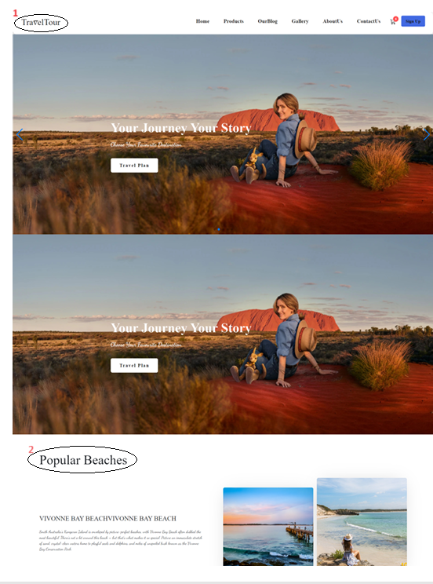

|  |  |  |  |
| --- | --- | --- | --- |
| **No** | **Type** | **Validation** | **Action** |
| 1 | Click |  | Navigation to Home page |
| 2 | Text |  | Introducing some popular beaches |

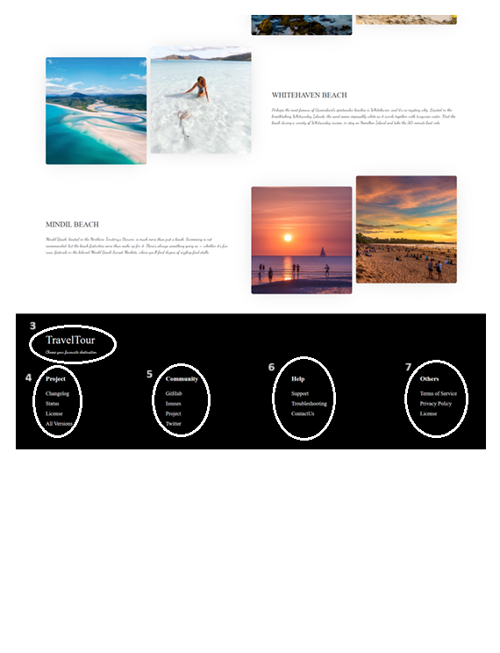

|  |  |  |  |
| --- | --- | --- | --- |
| **No** | **Type** | **Validation** | **Action** |
| 3 | Click |  | Click to go to the top of the page |
| 4 | Click |  | Navigation to Product Detail/11 |
| 5 | Text |  | Connect to Facebook, Twitter to Support |
| 6 | Click |  | Connect to the page that needs support |
| 7 | Click |  | Navigation to Privacy Policy |

1. **Product, Detail, and Cart Pages**

View, select products, quantities and place orders.

1. **Product page**

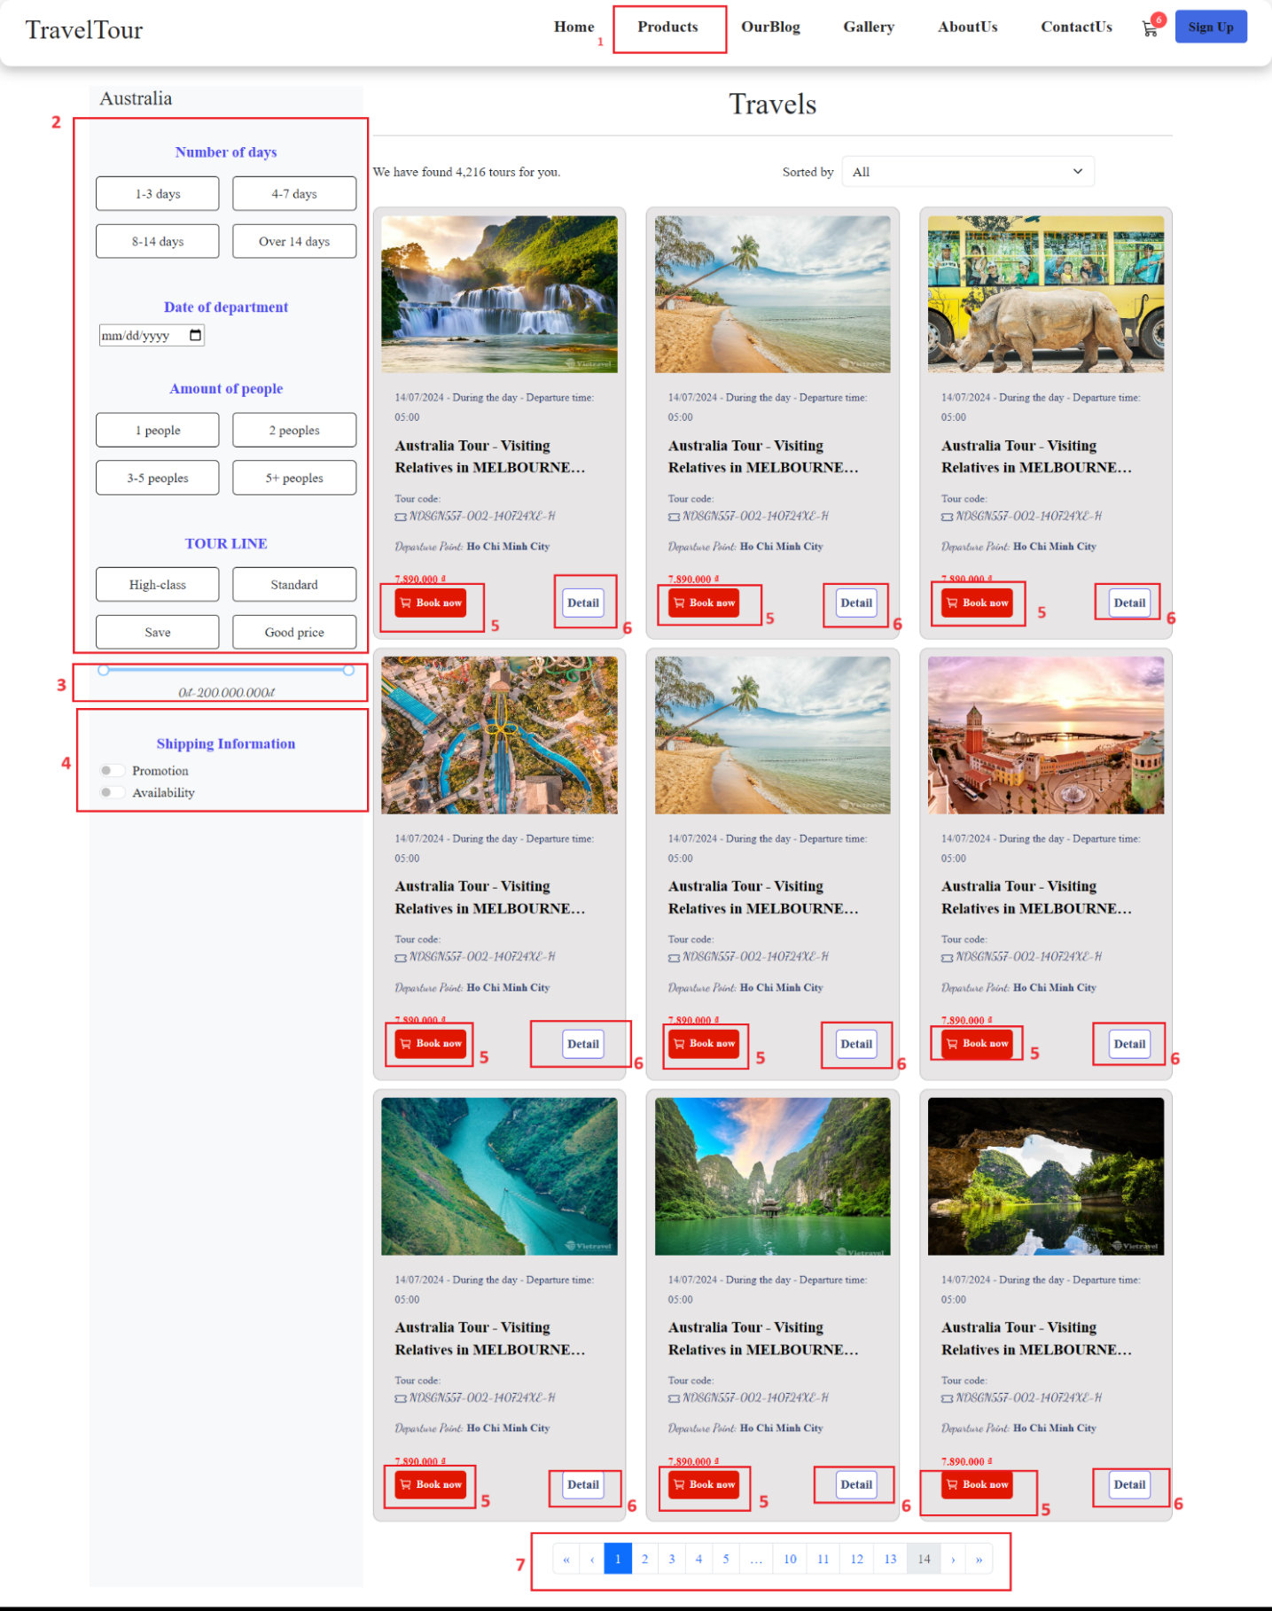

The Product page is used to view all the store's products, can be searched by name, category, and sorted by price

|  |  |  |  |  |
| --- | --- | --- | --- | --- |
| **No** | **Type** | **Validation** | **Action** | **Note** |
| 1 | Click |  | Navigation to Product page |  |
| 2 | Ratio |  | Sort by Category | We can search product after filter product |
| 3 | Ratio |  | Sort by price |
| 4 | Click |  | Reset filter |  |
| 5 | Click |  | Add product to cart |  |
| 6 | Click |  | Navigation to Detail |  |
| 7 | Click |  | Product pagination |  |

1. **Product Detail Page**

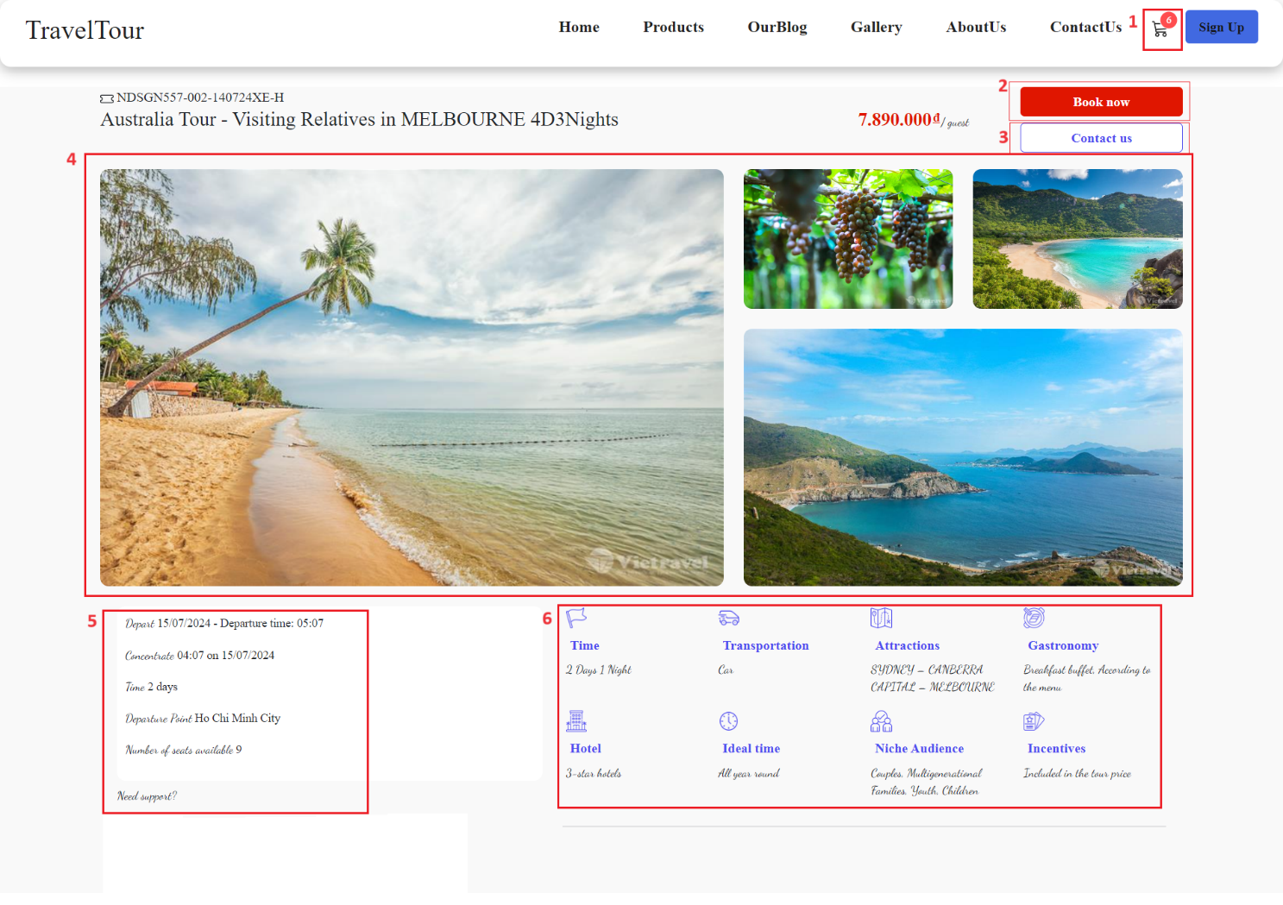

The Product detail page is used to view product details: images, description, manual, etc.

|  |  |  |  |
| --- | --- | --- | --- |
| **No** | **Type** | **Validation** | **Action** |
| 1 | Click |  | Add product to cart, The selected product and quantity will be added to the cart |
| 2 | Click |  | Add product to cart, The selected product and quantity will be added to the cart |
| 3 | Click |  | Navigation to Contact us page |
| 4 | Click |  | View image |
| 5 | Click |  | [Show](https://dictionary.cambridge.org/dictionary/english-vietnamese/show) [trip](https://dictionary.cambridge.org/dictionary/english-vietnamese/trip) [information](https://dictionary.cambridge.org/dictionary/english-vietnamese/information) |
| 6 | Click |  | [Show](https://dictionary.cambridge.org/dictionary/english-vietnamese/show) services included [in](https://dictionary.cambridge.org/dictionary/english-vietnamese/in) [the](https://dictionary.cambridge.org/dictionary/english-vietnamese/the) [trip](https://dictionary.cambridge.org/dictionary/english-vietnamese/trip) |

1. **Cart Page**

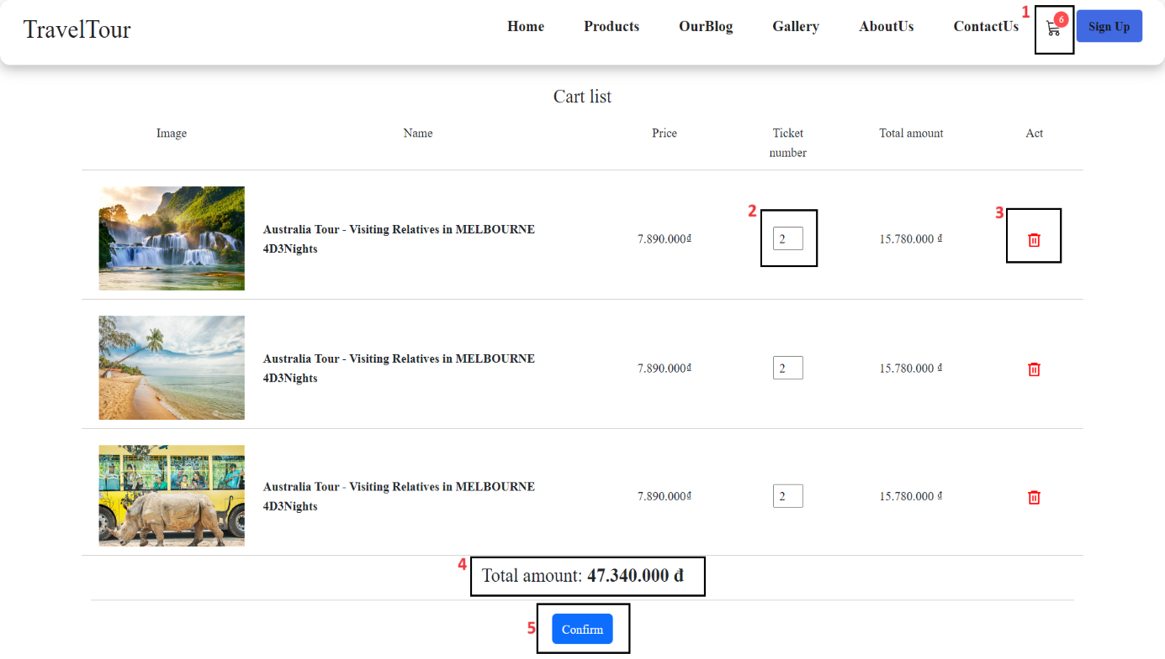

The Cart page is used to view the shopping cart, change quantities, or delete products. Then proceed to enter payment information below.

|  |  |  |  |
| --- | --- | --- | --- |
| **No** | **Type** | **Validation** | **Action** |
| 1 | Click |  | Navigation to Cart page |
| 2 | Click |  | Press ‘- to decrease’ or ‘+ to increase’ the quantity (min= 0 => delete product; max = quantity in stock). |
| 3 | Click |  | Delete product |
| 4 | Click |  | Show Payment information |
| 5 | Click | Check Out Success | Submit payment  When submitted successfully, all products added to the cart will be deleted. |

1. **User**

Create an account, log in to enjoy benefits from members

1. **Logi**n

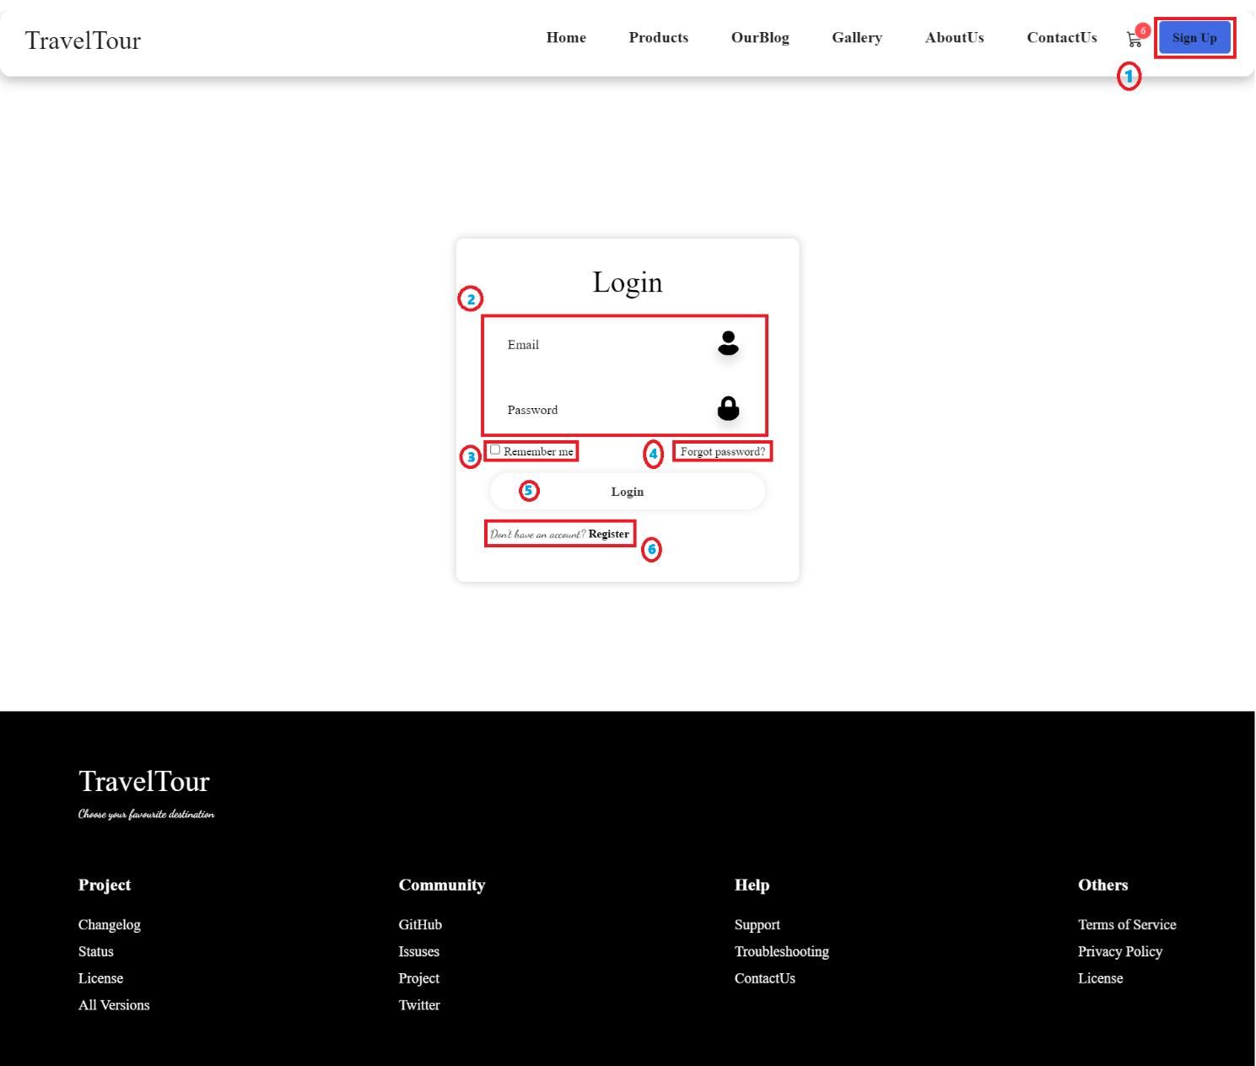

Log in to the site if you already have a member account

|  |  |  |  |
| --- | --- | --- | --- |
| **No** | **Type** | **Validation** | **Action** |
| 1 | Click |  | Navigation to Login page |
| 2 | Text | Username isRequired  Password is required  The Email or Password is incorrect. | Enter username and password to log in |
| 3 | Click |  | Remember the login account |
| 4 | Click |  | Show Forgot password information |
| 5 | Click | Check email, password | Login success then navigate to HomePage |
| 6 | Click |  | Navigation to Register page |

1. **Register**

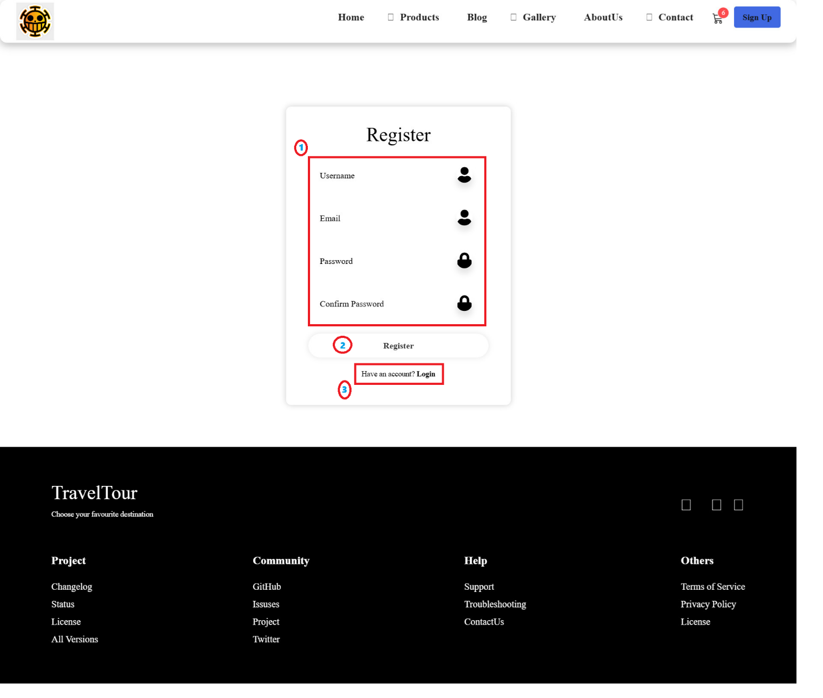

Register for a member account

|  |  |  |  |
| --- | --- | --- | --- |
| **No** | **Type** | **Validation** | **Action** |
| 1 | Text | Email is required  Password is required  Confirm Password is required  Confirm Password isn't match  Full Name is required  User Name >=5 characters | Enter information to register (boxes marked with * are required) |
| 2 | Click |  | Register success and navigation to Login page |
| 3 | Click |  | Navigation to Login page |

1. **Blog**
2. **Our Blog**

Introducing favorite dishes and how to prepare them.

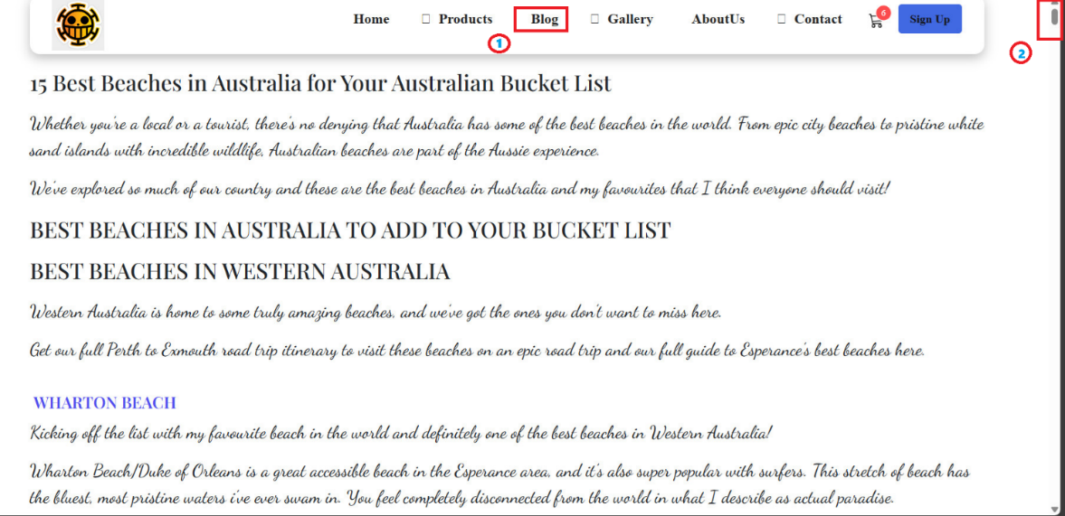

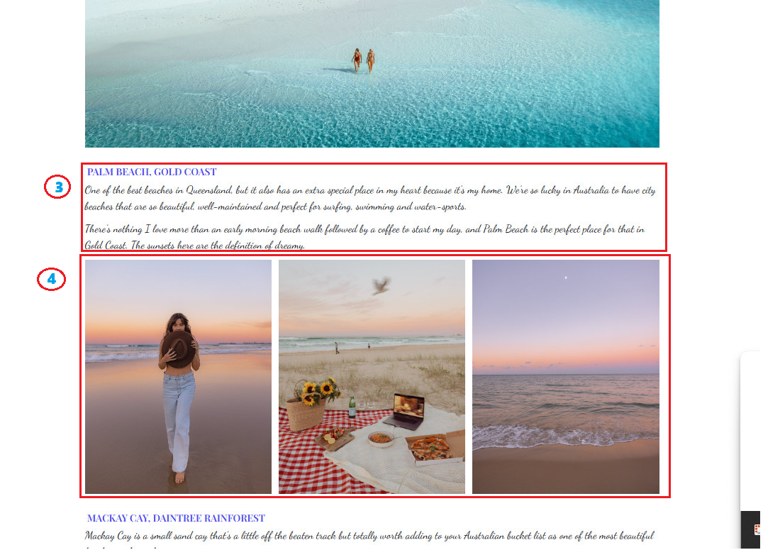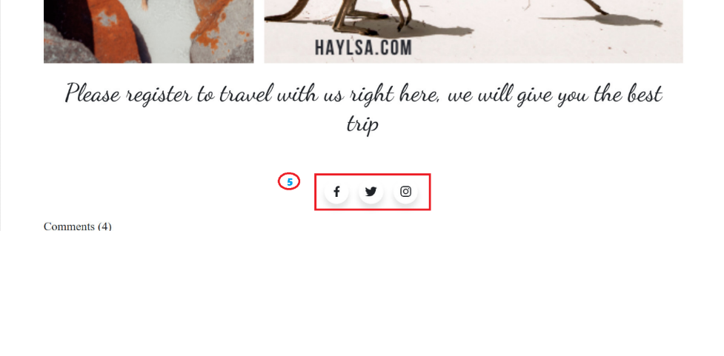

|  |  |  |  |
| --- | --- | --- | --- |
| **No** | **Type** | **Validation** | **Action** |
| 1 | Click |  | Navigation to Our Blog |
| 2 | Click |  | Navigation to Scrolldown |
| 3 |  |  | sea ​​description |
| 4 | Click |  | Description of sea photos |

|  |  |  |  |
| --- | --- | --- | --- |
| **No** | **Type** | **Validation** | **Action** |
| 1 | Click |  | Navigation to Expert Tips |
| 2 | Click |  | Navigation to Expert Tip Detail |
| 3 | Click |  | Expert tip pagination. |

1. **Contact us, Feedback, About Us**
2. **Contact Us**

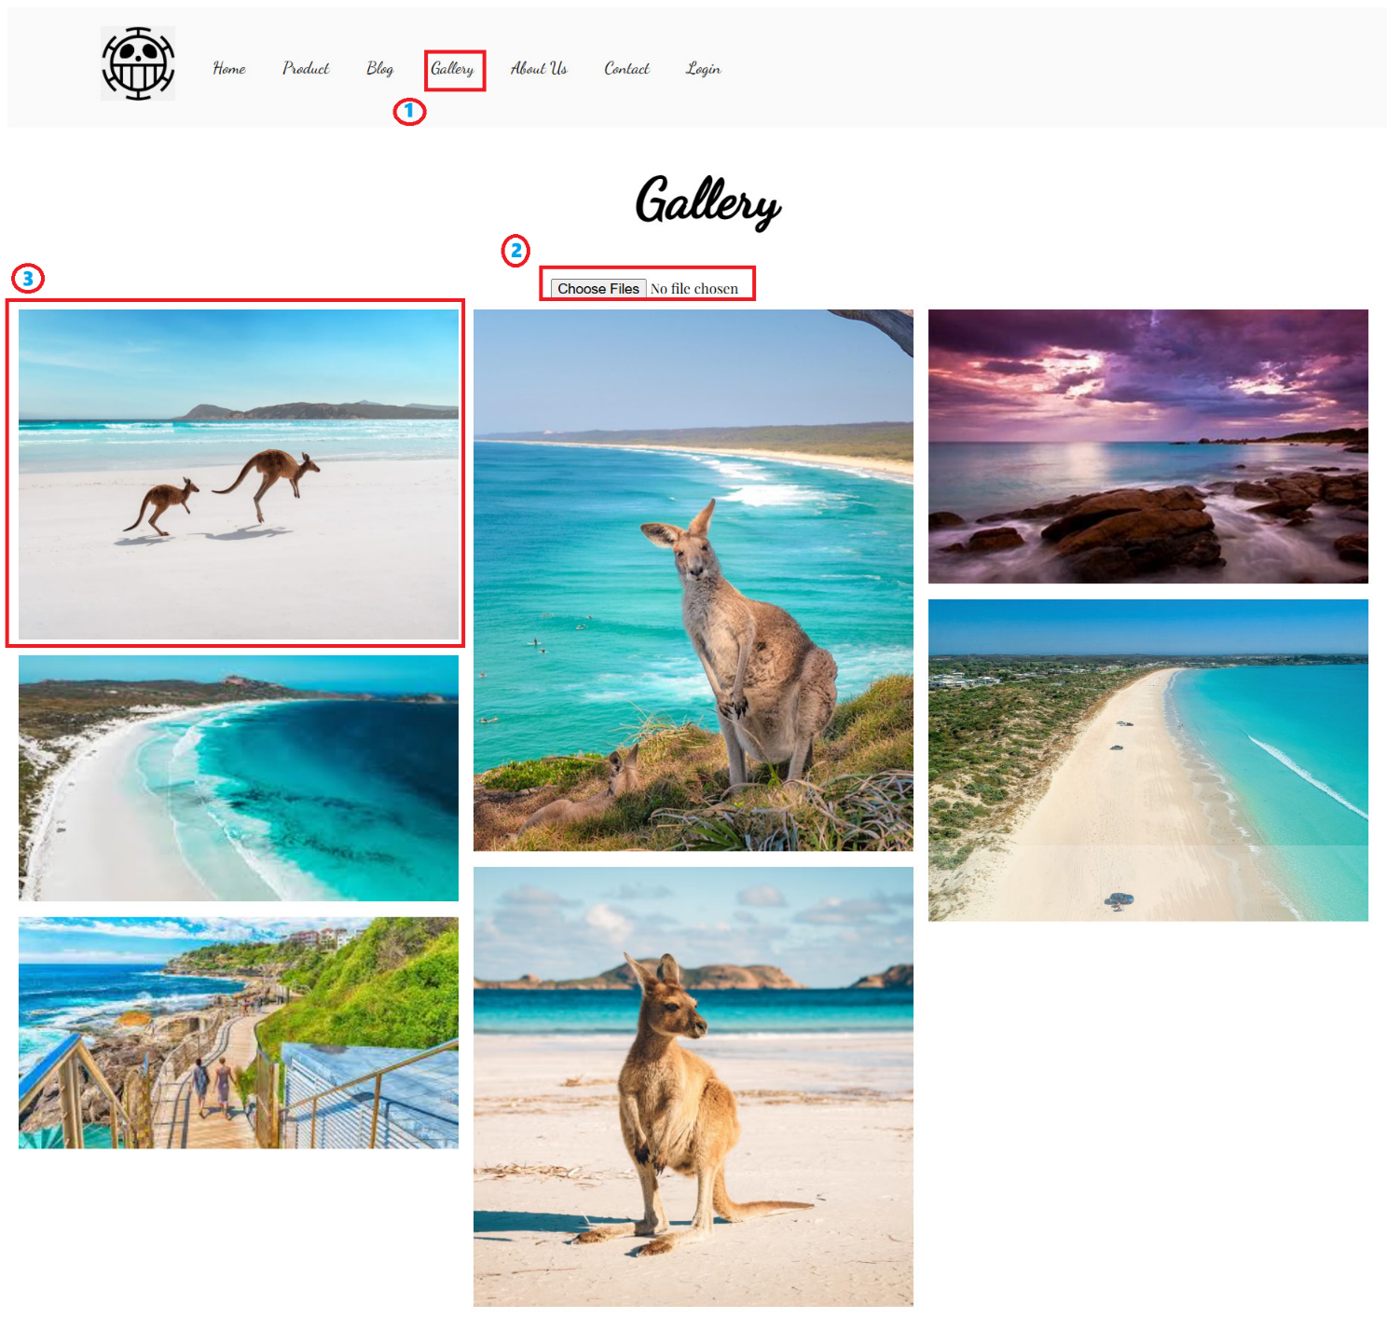

The Contact Us page is used to view contact information for Tasha, information and locations of Tasha's branches on the map, and user comments or complaints.

|  |  |  |  |
| --- | --- | --- | --- |
| **No** | **Type** | **Validation** | **Action** |
| 1 | Click |  | Navigation to Gallery |
| 2 | Click |  | Click choosefile to choose a photo |
| 3 | Click |  | Click on the photo to enlarge it |

1. **Feedback**

The Contact Us page is used to User feedback about Tasha

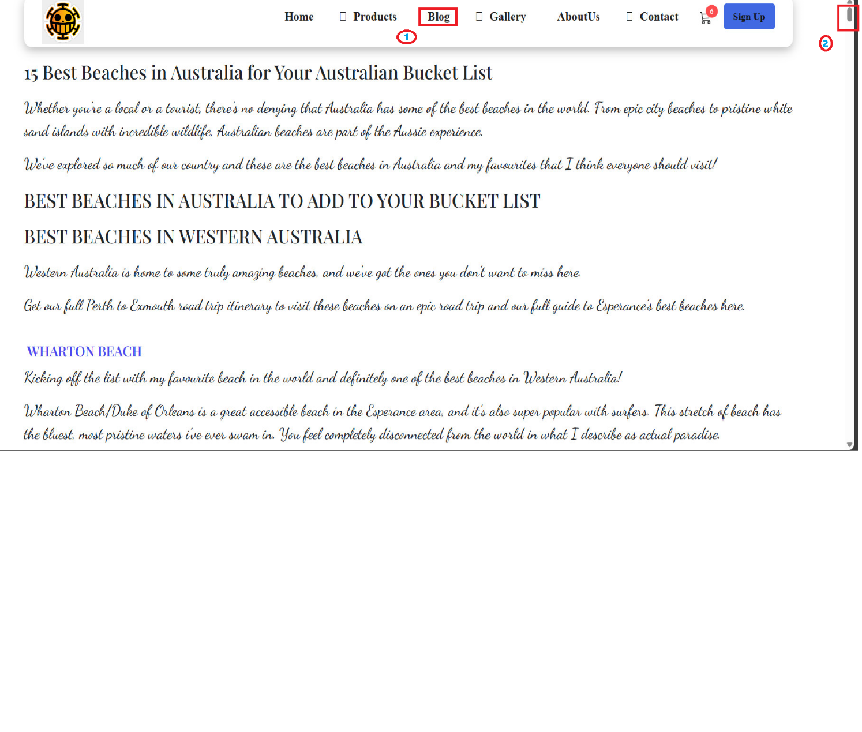

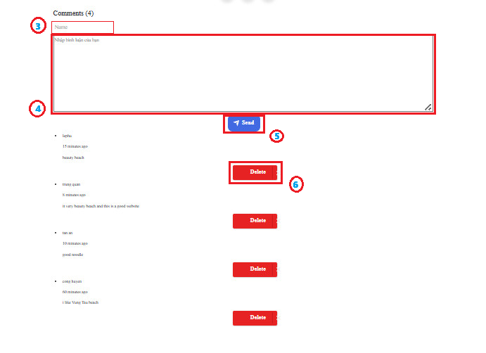

|  |  |  |  |
| --- | --- | --- | --- |
| **No** | **Type** | **Validation** | **Action** |
| 1 | Click |  | Navigation to Feedback |
| 2 | Ratio | Type is required | select |
| 3 | Text | Required | Enter feedback text |
| 4 | Click | Thank you for your Feedback ! | To submit form |

1. **About Us**

Shows the establishment process and information about Tasha.  
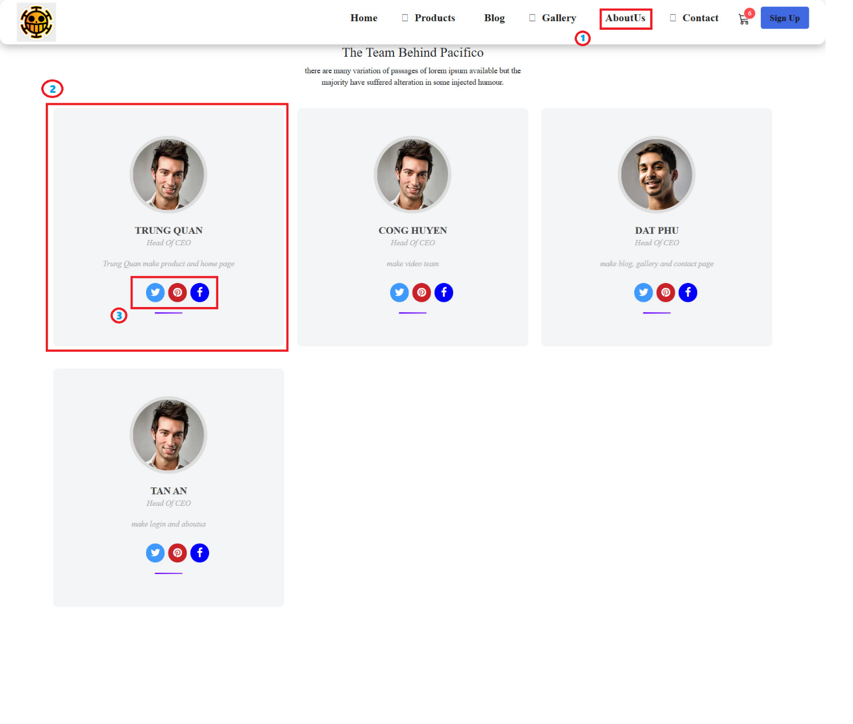

|  |  |  |  |
| --- | --- | --- | --- |
| **No** | **Type** | **Validation** | **Action** |
| 1 | Click |  | Navigation to AboutUs |
| 2 |  |  | personal information |
| 3 | Click |  | Display links of facebook, twitter, pinterss |

1. **Data**

The Data page is used to view information such as: user emails registered to receive incentive programs, feedback, registered accounts.

**User Login**: admin _ **password**: admin123

When logged in successfully, site will navigate to the data page

**Note:** If the login account is not 'admin' and goes to the data page, it will automatically navigate to the Not Found page

1. **Responsive web pages**

All Tasha pages (home, product, product detail, cart, blog, support, about us, login…)

are responsive in 3 sizes: mobile, tablet, laptop:

* Mobile format: width <= 767px
* Tablet format: 768px<=width<=1024px
* Laptop format: width>=1025px

**Below are some responsive example images:**

1. **Mobile**

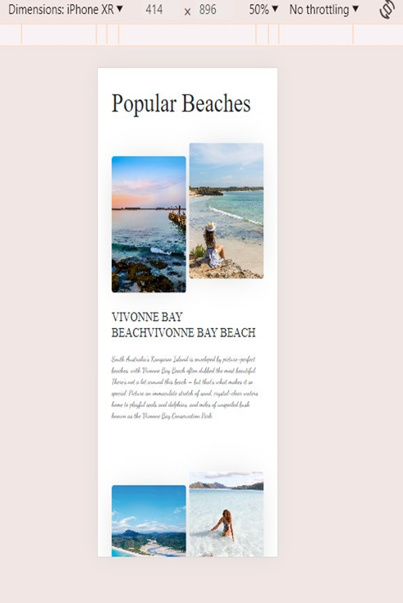

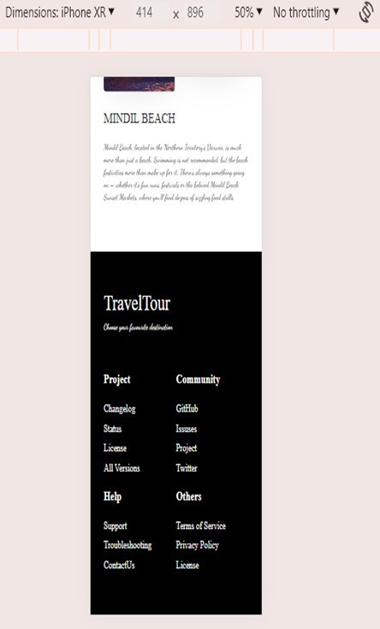

1. **Tablet**

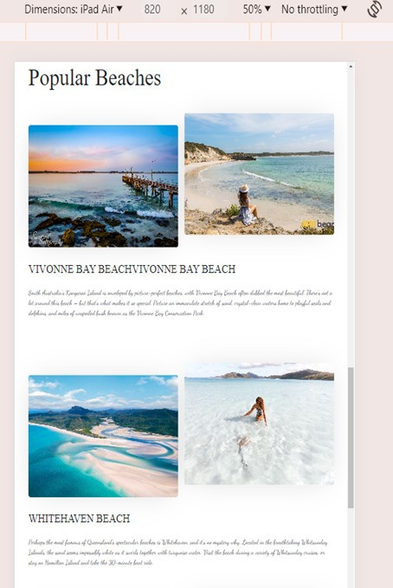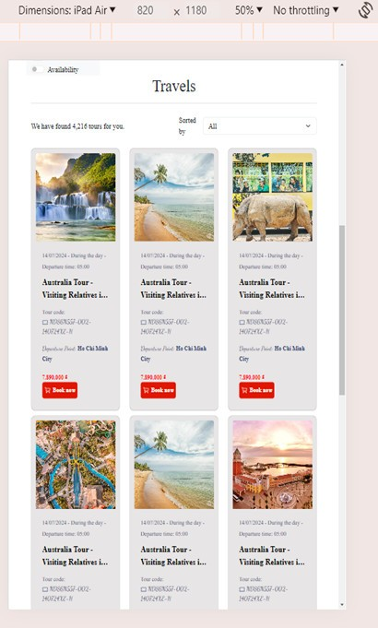

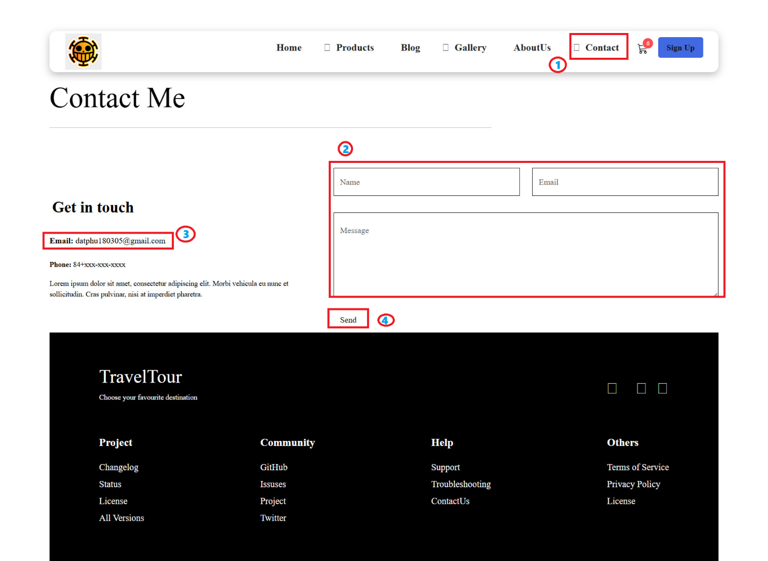

|  |  |  |  |
| --- | --- | --- | --- |
| **No** | **Type** | **Validation** | **Action** |
| 1 | Click |  | Navigation to Contact |
| 2 | input | Type is required | Input name,email,message |
| 3 | Click |  | Click send to my email |
| 4 | Click |  | Send to my email |

**Task Sheet**

|  |  |  |  |  |  |
| --- | --- | --- | --- | --- | --- |
| No | Member | Page Name | Planed Start Date | Actual Start Date | Status |
| *1.* | *LÊ THÀNH ĐẠT PHÚ* | Gallary | 06/24/2024 | 06/26/2024 | 100% |
| Blog | 06/24/2024 | 06/28/2024 | 100% |
| Blog Detail | 06/24/2024 | 06/29/2024 | 100% |
| *2.* | *VÕ TẤN AN* | Login | 06/24/2024 | 06/27/2024 | 100% |
| Feedback | 06/24/2024 | 06/28/2024 | 100% |
| *3.* | *ĐẶNG TRUNG QUÂN* | Product | 06/24/2024 | 06/27/2024 | 100% |
| ProductDetail | 06/24/2024 | 06/28/2024 | 100% |
| Product List | 06/24/2024 | 06/28/2024 | 100% |
| *4.* | *TẠ HUỲNH CÔNG HUYÊN* | Home | 06/24/2024 | 06/26/2024 | 100% |
| Cards | 06/24/2024 | 06/27/2024 | 100% |